**Tutorial 9: Transport Layer**

Q1. With reference to Figure 2, express in your own words the meaning of the output labelled A, B, C and D. (201409 TAR UC, Main) (4 marks)

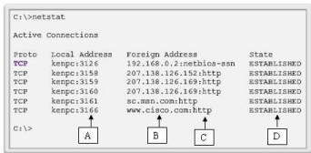

Figure 2: TCP connections running on a networked host.

| Label A | Source port number |
| --- | --- |
| Label B | Address or name of remote host |
| Label C | Destination port |
| Label D | Connection state |

Q2. Figure 1 is showing an output by using a command prompt of a host.

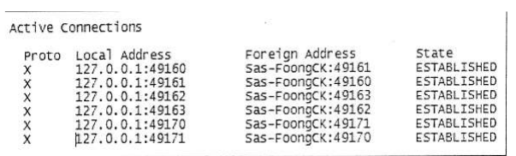

Figure 1: Connection status of a host

(i) What is the command that can be used to have an output of Figure 1? (201705 TAR UC, resit) (2 marks)

* netstat

(ii) What is the protocol name that is labeled as X in Figure 1?(201705 TAR UC, resit) (1 mark)

* Transmission Control Protocol (TCP)

(iii) Provide TWO (2) applications or services that are supported by the protocol that you have answered in Question 1 (ii). (201705 TAR UC, resit) (2 marks)

* File Transferring Protocol (FTP)
* Hypertext Transfer Protocol (HTTP)

(iv) Give ONE (1) example of a port number according to Figure 1. (201705 TAR UC, resit) (1 mark)

* 49170

Q3. During a connection establishment, TCP0 opens a connection using an initial sequence number (ISN) of 4918. The other party, TCP1, opens the connection with an ISN of 24463. In the data transfer phase, the TCP0 sends only one segment with data size of 1000 bytes. Then it sends a FIN segment to close the connection.

(i) Draw a three-way handshake diagram to show the values of sequence number and acknowledgement number for the three Transmission Control Protocol (TCP) segments during the connection establishment. (201703 TAR UC, resit) (8 marks)

|  |
| --- |

(ii) TCP provides mechanisms for flow control. List and explain the field in TCP header that is used for flow control. (201703 TAR UC, resit) (5 marks)

* TCP flow control function relies on a 16-bit TCP Header field which is Window Size.
* It is the number of bytes that the destination device of a TCP session can accept and process at one time.

(iii)With the aid of a diagram, illustrate FOUR (4) steps of TCP termination process. (201609 TAR UC, Main) (11 marks)

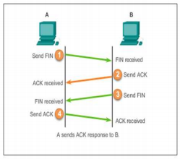

1. When the client has no more data to send in stream, it sends a segment with the FIN flag set.
2. The server sends a ACK to acknowledge the receipt of a FIN to terminate the session from client to server
3. The server sends a FIN to client to terminate the server to client session
4. The client will respond with an ACK to acknowledge the FIN from the server.

**EXTRA:**

